1. Home

"Turbogaz" PJSC- leader in development and manufacturing of turboexpanders for oil and gas industry and oil and gas equipment
«Turbogaz» public joint stock company – research and development company, main activities of which are research, development and implementation of turboexpanders, namely, low temperature turbine-refrigerator expanders at units of low-temperature separation of natural gas and energy-saving power turbine expanders for conversion of excess pressure of gas at gas distribution stations, gas distribution points and compressor stations into electric energy.
«Turbogaz» PJSC performs full technological closed loop – from research and development to supply of ready products, including supervised installation, commissioning works, training of servicing personnel, guarantee and post-guarantee servicing.
Our partners are the biggest gas producing enterprises and energy companies of Ukraine, the Russian Federation, Republics of Belorussia, Uzbekistan, Kazakhstan and far-abroad countries.
Our reputation is our asset. High quality, reliability and due fulfillment of contract obligations – this is the principle of work of our team.
Creating competitive machines, the company constantly develops either the sales market of our products, or the range of goods, strives to meet the requirements of customers and is open for mutually beneficial co-operation; with all participants of oil and gas market.
We long for uniting ideas of the future and long experience of the past, we want to offer our mite into development of main directions of activities of our clients from different corners of far-abroad and near-abroad countries.
Presenting this site of our company, we hope to become your long standing and reliable partner.

2. About

«Turbogaz» PJSC - leader in development and manufacturing of turboexpanders for oil and gas industry and oil and gas equipment
«Turbogaz» PJSC was established in 1975 by the decision of the Ministry of gas industry of the USSR as a main company for creating and implementation in the field of progressive energy technological equipment. Before 1991 the company was a member of «Gazprom» concern.
Today «Turbogaz» public joint stock company is scientific-production company, which has long practical experience of work in development, manufacturing and implementation of different types of equipment for boring, excavation, preparation, processing and transportation of oil and gas.
Status of a scientific organization is confirmed by the decision of board of the Ministry of fuel and energy of Ukraine No. 2 dated March 15, 2003, according to which «Turbogaz» PJSC relates to organizations, forming perspective scientific-technical politics in oil gas field.
At present «Turbogaz» PJSC consists of the following main departments: calculation-design bureau, «Turbogaz» pilot plant and testing area. Totally 500 employees work at «Turbogaz» PJSC.
Development of design documents is made by design bureau, with more than 100 specialists, including 5 PhDs 4 of them are corresponding members of Oil and Engineering academy of sciences of Ukraine, as well as Technology academy of the Russian Federation.
Intelligent potential of «Turbogaz» PJSC confirm more than 200 scientific articles, about 350 inventors certificates and patents for invention, 250 of which are implemented in the working equipment. 39 patents for invention were received only during the last three years.
All created technical decisions base on own developments or are made in cooperation with specialists of leading design and scientific-research institutes of Ukraine, the Russian Federation and other near-abroad countries.

2.1. History

«Turbogaz» PJSC, before All-Union scientific-manufacturing association (VNPО) «Soyuzturbogaz» was established in 1975 by the decision of the Ministry of gas industry of USSR, as a main company in creating and implementation in the field of state-of the-art energy technological equipment. Before 1991 the company was a member of «Gazprom» concern. In the first years of operation VNPО scientific and test-design works were devoted to researches, development and implementation of installations of low temperature gas separation with turbine-refrigerator expanders (ТDА) Т-3, ТКО-25/64 and development of new structures of turbine expanders of BТDА-5-100 type. Simultaneously were performed the developments of new gas turbine, gas compressor units (GCU) with 6.0 – 12.0 МW power aircraft drive.
At that time were manufactured the first test samples of turbine expander units of BТDА-5-100, designed for gas flow of 5.0 mln.m3/24 h and for 10.0 МPa pressure.
Units of BТDА-5-100 type were widely used at the fields of Ukraine, Middle Asia and Komi ASSR; big units of BТDА -10-13 type with gas flow of 10.0 mln.m3/24 h at pressure to 13.0 МPа were implemented at large Yamburgsk field (Russia), a number of turbine expanders are implemented at gas processing plants.
Obtained knowledge and deep understanding of the essence and peculiarities of technology of gas preparation for transportation in the North conditions allowed development and in 1986 – 1993s supply of 63 units for installations of complex gas processing units (CGPU) of Cenomanian deposits and 14 units for Valanginian deposits of Yamburgsk gas condensate field (GCF), the units till today provide gas preparation for transportation and obtaining of gas condensate.
Implementation of turbine expanders at the fields of Middle Asia was made at sites of All-Union production enterprise «Turkmengazprom» and All-Union production enterprise «Uzbekgazprom». It was provided to create one test-industry line with units in the units of low temperature separation in:
main buildings No. 1 at Shatlyk field (Turkmenistan);
main buildings of Kirpichli field (Turkmenistan);
Kultak field of GPU «Mubarekgaz» (Uzbekistan).
In 1977 by the decision of Mingazprom of USSR was made serial supply of 24-х turbine expanders of BТDА-5-100 at Shatlyk field, which were introduced into operation in 1980.
In the period of 1980-1981 for the first time in the world practice in the technology of low temperature gas separation was used a turbine expander unit (BТDА-5-100) for work with low-sulphur natural gas. The unit underwent long time industry testing at Kultak field (Uzbekistan). During work the unit for 24 hours provided necessary temperature of natural gas separation. Parameters corresponded to technical conditions for the unit.
At the same years in the company went on work on manufacturing and implementation at compressor stations of gas turbine, gas compressor units and a number of new superchargers of natural gas. In 1977 the Ministry of gas industry of the USSR determined the All-Union Scientific Production Enterprise «Soyuzturbogaz» the main organization on creating of block and block-transportable ship-and-aircraft-engines-based gas turbine power stations for the needs of gas and oil industry, as well as for national economy. A number of block module power stations of BGТEhS-24UМ type was created in the period from 1981 till 1984.
In future was developed new Eh-1000 transportable power station with power of 1 МW. Eleven such power stations were supplied to the objects of «Severgazprom» production enterprise, «Tumengazprom» production enterprise, «Turkmengazprom» production enterprise. Later were developed block-transportable power stations with power of 2.5 and 6 МW. In total were supplied 20 gas turbine power stations with total power of more than 300 МW.
At the same period were performed thorough researches aimed to select optimal diagrams of energy saving turbine expanders at gas distribution stations (GDS), gas distribution points (GDP) and compressor stations (КS), in which the energy of excess gas pressure is converted into electric energy. As a result in 1986 for the first time in the USSR was manufactured UТDU-2500 energy saving turbine expander with power of 2500.0 kW for GDS. Industrial model of the expander is being operated at GDS No. 7 of Dnepropetrovsk since 1991 till present.
In 1994 VNPO «Soyuzturbogaz» all-union scientific production enterprise became «Turbogaz» open joint stock company.
Among new developments of that period should be outlined preventers for drilling and pullout of a hole, with work pressure of 21, 35, 70 and 105 МPа.
BGP-70 caterpillar cart-horse with carrying capacity to 70 tons was created for the first time in Ukraine. More than a hundred sets of wellhead equipment, in usual and corrosion resistant performance were implemented at different gas fields of Ukraine and the Russian Federation.
At the end of 2001 the company was headed by the President О.S Ilyutko and Chairman of the Board, General director О.V. Kuprygin. Under their leadership was improved organization structure, search, winning and broadening of trade markets of products in Ukraine and CIS countries became the bases for further development of the joint stock company. Attention is paid to patching up the international relations, business cooperation with gas workers of other countries, primarily, of the Russian Federation, Republic of Belorussia, Republic of Kazakhstan, Republic of Uzbekistan, Turkmenistan and Islam republic of Iran.
At present the joint stock company has developed and manufactures turbine refrigerator and low temperature units with productivity from 2.4 tо 10.0 mln. m3/24 h at pressure to 13.0 МPа for a wide range of gas compositions, including sour, work at fields with condensate factor to 300 gr/nm3 for operation at different climatic conditions.
Multifield activity of a company, namely creating of different types of equipment for drilling, production, preparation, processing and transportation of gas, let us learn all peculiarities of technological processes, which are applied in the field. Basing on the obtained knowledge and gained experience, we design the effective equipment, solve specific tasks not only as designers of a turbine techniques, but also as developers of the technology of low temperature gas separation. It lets reducing time, necessary for performance of the whole set of work from the start of design till finishing of acceptance testing. Cooperation with design institutes of Ukraine, the Russian Federation, Republic of Uzbekistan, developers of projects on developing of the fields, lets us previously save the initial data on the perspective fields of oil and gas for performance of deep and thorough researches of the existing technologies of production and preparation of gas, learn peculiarities of composition of the produced natural gas and conditions of operation.
With the analyzed initial data, developed programs and procedures of calculation of turbine expanders for different compositions of gas and layer pressures, we create in the shortest terms turbine expanders fully corresponding service conditions with parameters, providing its most effective work.
Presence in our organization of qualified technologists on preparation of natural gas with more than 30-years of experience of work at fields of Ukraine, the Russian Federation, Republics of Azerbaijan, Uzbekistan and Turkmenistan, allows in cooperation with the specialists of gas producing companies operatively retune the modes of operation of the turbine expanders at changing of parameters of work of the with the purpose of optimization of production of hydrocarbon raw material. As well as give qualified recommendations on technology pf gas production and processing.
Today «Turbogaz» public joint stock company is the scientific-manufacturing company, which has long term practical experience in development, manufacturing and implementation of different types of equipment for drilling, production, preparation, processing and transportation of oil and gas. Activity of the stock company includes all stages of manufacturing from researches and developments till supply of ready products «turn key», including building-installation and commissioning works, training of the servicing personnel, guarantee and post guarantee servicing.

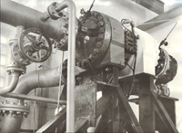
Т-3 turbine expander for installation of complex gas preparation No.11 Shebelinka gas condensate field (Ukraine)
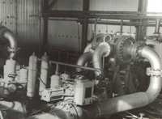
ТКО-25/64 turbine expander
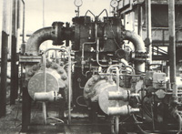
BTDА-5-100 turbine expander at test stand
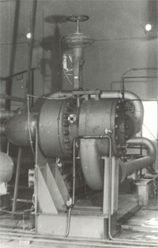
BТDА-2.4-3.5UKhL1 turbine expander
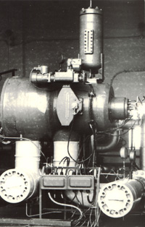
BТDА-5-10-3U1 turbine expander
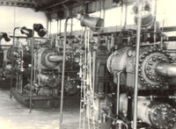
Turbine expanders at CGPU No.8 of Vyktylskiy gas condensate field (Russia)
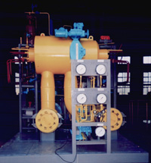
BTDА-10-13 turbine expander
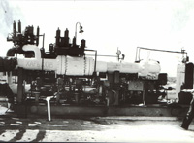
BTDА -5-100 at the 2-nd process train GS-1 of Shatlykskiy gas condensate field (Turkmenistan)
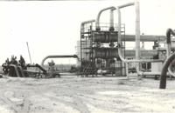
Unit of low temperature separation with turbine expander at Kultak GCF (Uzbekistan)
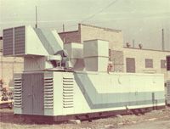
EhG-1000 gas turbine power plant
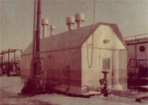
UKS2-300 energy saving turbine expander

2.2. Implemented projects

«Turbogaz» PJSC trade mark for more than 30 years symbolizes effective energy saving equipment and up-to-date energy saving technologies of preparation of gas and manufacturing of electric power in particular:
- 190 turbine refrigerator expanders are supplied to the gas condensate fields of Ukraine, the Russian Federation, Republics of Azerbaijan, Uzbekistan and Turkmenistan;
- 7 energy saving turboexpanders are installed on the objects of gas transport system and energetic system of Ukraine, the Russian Federation and Republic of Belorussia;
- 212 gas compressor units are supplied to compressor stations of the Russian Federation;
- 20 gas turbine power plants with total power of more than 300 МW are supplied to the objects of the Russian Federation, Republics of Turkmenistan and Azerbaijan;
- more than 900 sets of well equipment are supplied to gas condensate fields of Ukraine, the Russian Federation and Latvia;
- more than 100 sets of wellhead equipment are supplied to the gas condensate fields of Ukraine;
- 16 gas condensate fields of Ukraine are fully equipped for gas preparation.
For the period from 1990 till 2011 «Turbogaz» PJSC implemented turboexpanders on the following sites:
Turboexpanders in installations of natural gas complex preparation
Name of field | Country | Output mln.m3/24h | Quantity of the supplied units, pcs
«Yamburggazdobycha» complex gas treatment plant | Russia | 8-11 | Senoman 63  Valanzhin 14
Glebovskoye complex gas treatment plant of «Chernomorneftegas» | Ukraine | 2,5-3,5 | 3
GPU «Kharkovgazdobycha» NGP «Yulyevskoe» | Ukraine | 2,4 | 1
GPU «Poltavagazdobycha», GS «Kotelva» | Ukraine | 1,5-2,7 | 1
GPU «Shebelinkagazdobycha» GS «Krestishe» | Ukraine | 4 | 3
JSC «Uzgeoburneftegazdobycha», oil and gas condensate field «Kokdumalack» | Uzbekistan | 4,9 | 4
JSC «Uzgeoburneftegazdobycha», oil and gas condensate field «Kokdumalack» | Uzbekistan | 2,9 | 1
GPU «Poltavagazdobycha», GS «Solokha» | Ukraine | 3-5,5 | 1
OJSC «Uztashkineftgaz», UBPS-2 «Shurtan» (propane/butane mix unit) | Uzbekistan | 9,0 | 1
OJSC «Uztashkineftgaz», Zevardy field | Uzbekistan | 2,9 | 4
OJSC «Uztashkineftgaz», Pamuck field | Uzbekistan | 2,9 | 4
GPU «Poltavagazdobycha», GS «Mashevka» | Ukraine | 1,2 | 1
GPU «Poltavagazdobycha», GS «Chutovo» | Ukraine | 0,5 | 1
GPU «Poltavagazdobycha», GS «Skhidna Poltava» | Ukraine | 0,5 | 1
GPU «Poltavagazdobycha», GS «Abazovka» | Ukraine | 0,7 | 1
Energy saving turbine expanders
Name of field | Country | Q-ty | Installed capacity,  kW
UMG «Kharkovtransgaz» Subsidiary Company of «Ukrtransgaz», GRS-7 of Dnepropetrovskiy LP UMG | Ukraine | 1 | 2500
Minskaya YEhTS-4 | Belarus | 2 | 2500
GRP-2, Novolukoml city | Belarus | 1 | 2500
GS «Solokha», GPU «Poltavagazdobycha» | Ukraine | 1 | 2500
GDS, Odessa * | Ukraine | 1 | 4000
GDS, Zaporozhye* | Ukraine | 1 | 4000
GDS, Severodonetsk | Ukraine | 1 | 4000
RUP "Gomelenergo", Gomelskaya ТEhTs-2 | Belarus | 1 | 4000
* - new equipment is being supplied
Knowledge, based on long-term experience of design, manufacturing, implementation of turbine refrigerator techniques, its operation, understanding of essence and peculiarities of the processes, as well as established relations with design and scientific-research institutes of Ukraine and the Russian Federation allow «Turbogaz» PJSC creating high-efficiency low temperature and Energy saving turbine expanders.

2.3. Career
For more than 30 years of fruitful operation «Turbogaz» PJSC has gained reputation of a reliable manufacturer and supplier of equipment for fuel-energy complex.
Taking into account the continuous company growth and concluding of the new Contracts the company is interested in hiring skilled technical experts, designers, engineers-designers, production engineers of Electrical Control & Instrumentation and Automatic control system. The company proposes interesting work in perspective fields of development of turbine expanders and gas industry equipment, favourable conditions of professional and carrier growth, social package, formal hiring, modern methods of labour organization and respectable wages.
Please, send your CVs for consideration to human resources department of «Turbogaz» PJSC
tel.(057) 7520952
turbogaz@ukr.net

2.4. Certificates and licenses
Certificates and licenses

«Turbogaz» PJSC pays much attention to quality of the designed and manufactured products. In 2004 the company received the certificate of Quality control system ISO 9000, issued by the National certification authority.

Certificate of
Quality control system
ISO 9000
The company has licenses for development of design documents, manufacturing, installation and commissioning of technological equipment of fuel-energy complex.
• Certificate for quality management No. IIА 2.003.1213 dated July 30, 2004 for conformity to ISO 9001.2000.
• Permission (license) No. 00.11.0.08.01.90214.147 for «Development of gas turbine power plants and turbine expanders». Issued to «Turbogaz» PJSC on October 13, 2000 by GOSNADZOROKHRANATRUDA of Ukraine.
• License No. 486525 Series АА for construction activities (installation of internal engineering networks, systems, devices and measuring equipment, installation of technological equipment, gas supply and gas equipment, commissioning works of fuel-energy complex). Issued on February 27, 2003 by State Committee of Ukraine on construction and architecture.
• State license No.011430 ГСЛ (No.011430 GSL) for performance of architecture, town-planning and construction activities on the territory of Republic of Kazakhstan according to the enclosed list (commissioning works of oil and gas industry equipment, mining equipment). It is issued on April 11, 2003 by the Committee on building affairs of the Ministry of industry and trade of republic of Kazakhstan.
• Permission No. 391.03.30-31.62.4 for manufacturing and application of manufacturing devices for explosion proof electrical equipment. Issued to «Turbogaz» PJSC on April 14, 2003 by GOSNADZOROKHRANATRUDA of Ukraine.
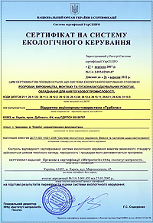
Certificate of
the Ecological Monitoring System
ISO 14000
In 2004 the joint stock company was awarded the title «The best company of Ukraine 2004» in nomination «Oil and Gas Industry», and was also awarded a certificate of the winner of «The best employer of 2004» competition. In 2005 the company was recognized the winner of All-Ukraine competition of the quality of products «100 Best Goods of Ukraine», and in 2006 was awarded the sign – «Leader. Industry and Entrepreneurship of Ukraine 2006».
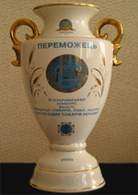 |  | 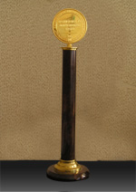
Award - «100 Best Goods of Ukraine» | Sign «The Best Company of Ukraine 2004» | Sign «Leader. Industry and Entrepreneurship of Ukraine 2006»

3. Equipment

3.1 TURBOEXPANDERS

3.1.1 LOW TEMPERATURE TURBOEXPANDERS (NTDA)
Application of automated complex gas treatment plants with the use of turboexpanders in the technology of gas treatment at gas condensate fields is an essential factor of increase of fields’ technical level.
NTDA are intended for obtaining of deep cold in installations of natural gas preparation and processing, providing temperature difference to 55 °С. According to the temperature at outlet from the unit, turbine expanders can be used:
- for natural gas cooling (minus 2 °С)
- for extraction of C5+ fraction (to minus 30 °С)
- for obtaining of propane-butane fraction (to minus 80 °С)
Depending on the composition of natural gas usage of NTDA allows extracting target components, including:
methane fraction;
ethane fraction;
propane-butane fraction;
broad fraction of light hydrocarbons;
stable natural gasoline;
normal-butane;
isobutane
isopentane;
normal-pentane;
pentan- hexane fraction.
At «Turbogaz» PJSC are developed and manufactured turboexpanders with productivity from 0.5 to 10.0 mln. m3/day at gas pressure to 13.0 МPа, calculated for a wide range of gas composites (including sour) and works at fields with condensate factor to 100 gr/nm3.
We operatively perform adjustment of characteristics of the unit at mix of streams from different fields, which have different composition and thermobaric characteristics.
At development of each new structure are used recent developments of science and techniques, state-of-the-art technologies and new materials, which let reliably operate in any climatic conditions from arctic to south latitudes. Thus in the structure of turboexpanders with participation of S2M French company (magnetic bearings and high speed motors) was applied magnetic suspend of rotor, that allowed to resign from the system of lubrication of bearings.
Results of industry operation confirm effectiveness of use of turboexpanders, as well as opportunity of their application for preparation of natural gas, at gas condensate fields with different gas condensate characteristics at different levels of operation, in particular at stage of declining production.
All types of industry turboexpanders depending on their purpose operate with defined temperature fall on cooled gas stream. This parameter is determinative at design, «Turbogaz» PJSC develops and manufactures units individually at specifically set-up parameters of this or that technology taking into account climatic conditions of operation.
  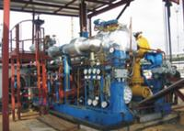
  NTDA-2,4-6,4-UKhL4 (OGF "Yulyevskoye", Ukraine)
  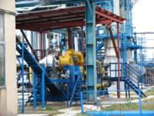
  NTDA-2,4-6,4-UKhL4 (GS "Kotelva", Ukraine)
  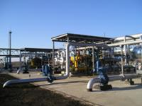
  ТDА-4,0-3,0-UKhL2 (GS "Krestishche", Ukraine)
  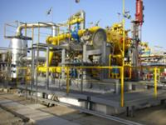
  ТDА-4,9-6,8-U1 (UNTS oil and gas condensate field "Kokdumalack", Uzbekistan
  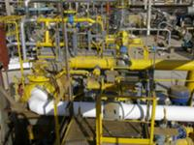
  ТDА-2,9-6,8-U1 (UNTS oil and gas condensate field "Kokdumalack", Uzbekistan)
  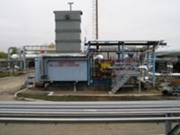
  UDEhU-2500-UKhL2 (GDS "Solokha", Ukraine)
  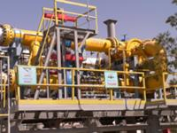
  МТDА-9,0-4,5-U1 (UPBS gas condensate field "Shurtan", Uzbekistan)
  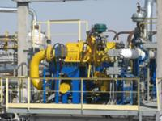
  МТDА-2,9-6,8-U1 (UKPG "Zevardy", Uzbekistan)
  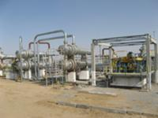
  MTDA-2,9-6,8-U1 (UKPG "Pamuck", Uzbekistan)
  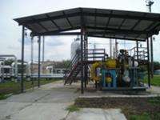
  MTDA-1,2-3,2-MP-U2 (UKPG "Mashevka", Ukraine)
  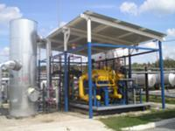
  MTDA-0,5-4,0-MP-U2 (UKPG "Skhidna Poltava", Ukraine)
  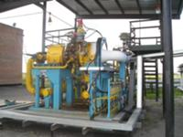
  MTDA-0,5-3,8-MP-U2 (UKPG "Chutovo", Ukraine)

Advantages of turboexpanders technology
High profitability. Application of low temperature turboexpanders allows increasing 3-4 times operation temperature fall at field in comparison with throttling and increase condensate output from gas in average in 2-3 times. Due to supplementary output of propane-butane and stable condensate the payback period of units reduces to one year.
Energy saving and ecology. Technology of low temperature separation with use of turbine expanders – energy saving technological process, without consumption of external sources of energy, in comparison with alternative variants of development of gas condensate fields: ammoniac and propane vapor-compressor refrigeration machines or absorbent refrigeration units.
Durability of operation. Turbine expanders are applicable during the whole period of development of gas condensate fields, providing sufficiently larger drop of temperatures compared to the nozzle-effect with the drop of the wellhead pressure in the process of field exhaust.

3.1.2 ENERGY SAVING TURBOEXPANDERS (UTDU)

Energy saving turboexpanders (UTDU) are intended for production of electric power by recuperation of energy of natural gas excess pressure at units of its reduction - gas-distribution stations (GDS), at gas distribution points (GDP) of heat power plants and large industry companies.
At present «Turbogaz» JSC manufactures energy saving turboexpanders of own design with different power: 8kW, 300 kW, 500 kW, 1МW, 2,5МW; 4МW; 5МW; 6МW; 8МW; 12МW for input gas pressure to 7.5 МPа and with gas flow of 0.05-6 mln. nm3/24 h.
Theoretical researches and practical experience show, that natural gas excess pressure energy saving by turboexpanders greatly corresponds to tasks of energy saving as economy of fuel for electricity production and improvement of ecology environment.
  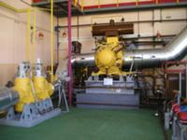
  UDEhU-2500-UKhL4 unit (TEhTs-4, Minsk, Republic of Belorussia)
  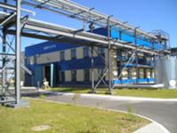
  Building with two UDEhU-2500-UKhL4 units (TEhTs-4, Minsk, Republic of Belorussia)
  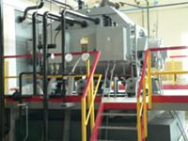
  Generator UDEhU-2500-UKhL4 (TEhTs-4, Minsk, Republic of Belorussia)
  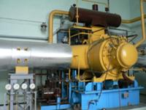
  UDEhU-2500-UKhL4 unit (GDP-2, Novolukoml, Republic of Belorussia)
  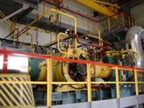
  UDEhU-4000-UKhL4 unit (TEhTs-2, Gomel, Republic of Belorussia)
  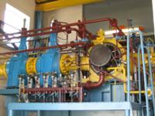
  UDEhU-2500-UKhL4 unit (GDS, Severodonetsk, Ukraine)

Joint company by order of National joint-stock company «Naftogaz of Ukraine» performed technical feasibility analysis of implementation of energy save turboexpander into gas transportation system of Ukraine.
Results of the above-mentioned scientific work were reflected in the decision of the Cabinet of Ministers of Ukraine dated July 27, 2006 No.436-р, according to which for realization of energy strategy of Ukraine is intended implementation of 54 energy saving turbine expanders at GDS of National joint-stock company «Naftogaz of Ukraine» before 2030.
For performance of this order «Turbogaz» PJSC was ordered development and supply of two installations UTDU-4000-UKhL4, with power of 4000 кW each, at GDS of Zaporozhye and Severodonetsk. In 2008 was introduced into operation energy saving turboexpander at GDS of Severodonetsk, and at GDS of Zaporozhye was performed supply of the equipment.
The biggest technical-economical effectiveness of use of turboexpanders can be achieved at combined manufacturing of electric power and cold. At GS «Solokha» GPU «Poltavgazdobycha» is implemented one-of-a-kind energy installation UDEhU-2500, with power of 2500 kW, intended for obtaining of cold at temperature level minus 30°С in the diagram of low temperature absorption with hour/year and output of simultaneous electricity production – 13024.8 thousd. kW of liquefied propane-butane fraction – 85.95 thousd. t/year, gas gasoline – 56.28 thousd. t/year, diesel fraction – 23.49 thousd. t/year. Payback period of this unit is maximum one year.
UTDU connecting diagrams
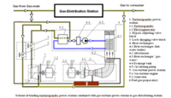
  Scheme of binding turboexpander power-station combined with gas-turbine power station to gas-distributing station
  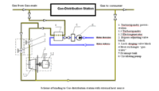
  Scheme of binding to Gas-distribution station with external heat source
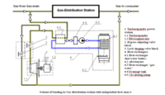
Scheme of binding to Gas-distribution station with independent heat source

Main advantages of electric power stations based on UTDU:
incremental cost of potential power, created by UTDU, is approximately 3 times less, then at creating of similar powers by traditional gas or steam turbines
heat input per 1 kW of produced electrical power is 2-3 times less than heat expenses in steam- and gas turbine units
gas economy (relative) to 60%
full absence of solid emissions, emissions of nitrogen oxides and sulfur into the atmosphere and emptying of process waters
efficiency factor is 0.7 to 0.8
short terms of payback - 2.5 to 5 years

3.2 Gas production equipment

3.2.1 MOBILE GAS WELL SURVEY PLANTS (PUIS)

PUIS-300-16-U1 plant is intended for operational research of underground gas storage well without gas release into atmosphere.
The first PUIS-300-16-U1 plant was developed, manufactured and supplied to Proletarskoe underground gas storage (PUGS) UMG «Kharkovtransgaz», where it passed acceptance tests in June 2004 and was accepted into operation.
Climatic performance of the installation is U, the category of location is 1, according to GOST 15150-69 it is permitted to operate the plant at outdoor air temperature from 243 К (minus 30ºС) tо 313 К (40ºС) and relative air humidity tо 100% at 298 К (25ºС), as well as with dust and atmosphere precipitations.
  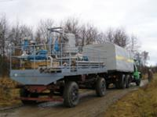
  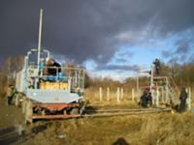

PUIS-300-16-U1 technical characteristics
Surveyed medium | hydrocarbon gas, condensate, deposit water, methanol, diethyleneglycol.
Method of well research | without gas release into atmosphere
Characteristics of the surveyed wells | wells with a wide range of flow rate, pressure and gas composition.
Nominal flow capacity of the plant’s separator, nm3/24 h | 300 000
Maximum flow capacity of the plant’s separator, nm3/24 h | 500 000
Estimated gas pressure at plant inlet, МPа | 16
Operating gas pressure at plant inlet, МPа | maximum 15.
Efficiency of separation of the separator, % | minimum 95.
Capacity of the condensate tank, l | 250
Temperature range of the surveyed and ambient media at which the plant maintains its serviceability, ºС | from minus 30 to 40
Weight of plant, t | maximum 8.0
Overall dimensions of the plant during transportation, mm, maximum: length/width/height | 8300/2600/4000
Main advantages of the plant:
well survey cycle in stationary modes without gas release into atmosphere;
offered plant provides an opportunity of survey of wells with a wider range. It is more mobile in comparison with the similar equipment;
notebook with the set of uninterruptible power supply unit and program software for data processing is available. It helps to perform on line visual inspection with printing of reports;
original structure of quick-detachable pipelines, elbows and new type of metal seals, reliable from the point of view of flow safety, allows connecting the plant to the well very quickly;
original structure of quick-detachable orifice allows replacing measuring diaphragms in a very short period of time.
Example of the entries of designation at order of PUIS: «Mobile gas well survey plant PUIS-300-16-U1 ТU U 29.5-00158787-043:2005».
The next stage in creating of mobile plants for well surveying became development and manufacturing of PUIS- 300-16-1-U1 plant.
The plant is intended for development of oil and gas condensate wells with the purpose to obtain a complex of oil and gas condensate characteristics of well standards of performance.
PUIS- 300-16-1-U1 not only saved advantages of its predecessor, such as mobility, quick installation-removal to wellhead equipment, but possesses a number of other advantages:
allows connecting to a well with operating pressure of up to 35 МPа;
has horizontal separator with the increased effectiveness of gas purification from liquid and mechanical mixtures due to application of 3 stages of separation;
tank for collection of liquid fraction of the increased volume to 1 m3;
separator and tank for collection of liquid fraction are equipped with heaters with the ability to connect to mobile vapor plant;
plant service plant is increased and is minimum 15 years.

PUIS-300-16-1-U1 technical characteristics
Surveyed medium | hydrocarbon gas, oil, gas condensate, deposit water, methanol, diethyleneglycol.
Maximum density of liquid in gas-liquid surveyed medium, сm3/m3 | 375
Nominal throughput capacity of the separator of the plant, nm3/24 h | 300 000
Maximum throughput capacity of the separator of the plant, nm3/24 h | 400 000
Pressure of liquid-gas mixture at input, МPа | 35
Effectiveness of gas purification from liquid and mechanical mixtures at nominal mode, % | 96
Productivity of liquid, m3/24 h | maximum 150
Operating medium temperature, ºС | minus 30-plus 50
Operating medium risks | explosive, fire risk
Internal operating volume of tank, m3 | 1
Internal full volume of tank, m3 | 1,3
Estimated pressure of tank, МPа | 1,6
Operating pressure of tank, МPа | 1,5
Operating pressure of gas liquid mixture in separator, МPа | 13,8
Estimated pressure of gas liquid mixture in separator, МPа | 16,0
Minimum pressure of gas liquid mixture in separator, МPа | 4,0
Operating medium temperature, ºС | maximum plus 50
Internal volume of separator, m3 | maximum 1.2
Temperature of a wall, minimum allowable during operation, ºС | minus 30
Weight of plant, t | not more 9,0
Plant overall dimensions at transportation, mm, maximum: length/width/height | 7630/2500/4000
Example of registration sign at order of the plant: «Mobile gas well survey plants PUIS-300-16-1-U1 TU U 29.5-00158787-074:2007».

3.2.2 Gas odorization system "Odotronic"

Gas odorization system “ODOTRONIC” is used as a part of gas distributing stations (GDS) of main pipelines and is intended for dosed injection of odour into the natural gas, which is supplied to the consumer.
Gas odorization system includes: odour block, odour capacity tank, monitoring and control unit, set of installation parts and connection cables. The system of gas odouring can be in one of three modes: operating, filling of feeder tank and removal of deposit from feeder tank. Change of modes is made with vents. Principle of operation is dosed injection of odour by electromagnetic valve of the odouring block under the influence of excessive gas pressure, created with the help of control unit and adjustment of pressure in the feeder tank.
The valve is operated by signals from the monitoring and control unit, and flow of odour is determined by the frequency of pulses of valve actuation and duration of a pulse. The valve can be installed directly to the pipeline. Necessary for providing the selected concentration, flow of odour is calculated by the monitoring and control unit at injection into it by hand or automatically the information about gas flow in pipeline.
All information about odour flow in the current period or for the report period is stored in the memory of monitoring and control unit and can be shown on the display or on monitor of operator’s computer.
Transportation of the system of gas odouring is made by railway, car or by air.
Optionally, to the volume of supply is included the odour capacity tank of 4 modifications, which differ in capacity: from 16 dm3 tо 96 dm3. The company has a right and performs installation and commissioning at the place of operation. Operation of the complex if supported by the maintenance department of the company.

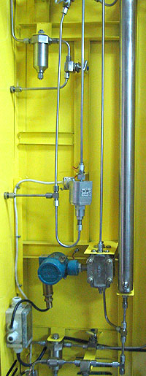

Main technical data
Flow of odour gas depending on the design styles, thousd. m3/h: | 0,05-50; 50-300; 300-500
Working pressure of odouring gas, МPа (kgf/cm)3/24 h | 0,1-1,2(1-12)
Automatically provided concentration of odour in gas, gr/thous.m3 | 5-16 (average 10,5)
Accuracy of odouring, %, not worse
Productivity as per odour, gr/h: | 0,25-800; 250-4800
Power-supply source:  - main – AC supply  - standby – battery | 220 V, 50±1 Hz;  24-27 V
Level of protection of electrical equipment (code of implosion protection – «explosion-proof enclosure») | Corresponding to zone 2 as per DNAoP 0.00-1.32-01
Ambient medium temperature, ºC | От -40 до +50

3.2.3 UPGM–220–25
complex gas treatment plant performed as modular factory-assembled units for gas and oil and gas fields with production capacity of 500-1500 thousd. m3/24 h
The plant is designed for gas processing before its transfer to different consumers as well as for production of stable condensate according to the low-temperature separation diagram with usage of cold at the expense of throttle effect.  The plant can be used for gas supply to both local consumers (municipal, agricultural and industrial establishments of inhabited locality within the radius of 50 km) and a main gas pipeline. The plant is performed as factory-assembled units and is remarkable for its mobility, compactness and simplicity of the structure. It is equipped with automatic control, regulation and protection systems based on a specialized microprocessor controller.  The plant is fit for operation in moderate macroclimate regions with “U1” climatic performance and “1” category of location according to GOST 15150-69.  Block transportation of UPGM–220–25 plant may be rail, motor and water transport.
  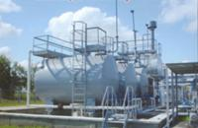
  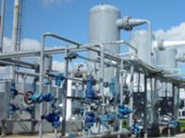
We offer the supply of the following complete set:
1. Filling units
2. Heat exchangers units
3. BS-1 INLET separators units
4. Low-temperature separators units
5. BZU-U1 metering assembly units
6. Disconnect BOU-16-280-103UG devices units from 1 to 15 wells
7. Metering separator units
8. BNI-520-16U1 inhibitor pumping unit
9. Pumped supplies of condensate and waste methanol, deposit water and condensate
10. Pumped supplies of heat carriers
11. Methanol storing tanks units
12. Units of industrial wastewater collection and degassing tanks
13. Turbine expander with a compressor or a generator
* - the complete set of the supply may alter depending on the Client’s requirements

3.2.4 Heat exchanger for compact gas treatment plants
Heat exchangers are intended for hearing (cooling) of high pressure gas or condensate by other heat exchanger. The last can be diethylene glycol (DEG) or natural gas  A number of heat exchangers with the surface of heat exchange from 1 to 50 m3, with flows of condensate or gas from 0,15 106 to 0,5 106 mm3/24 h and pressures from 1.7 to 16.0 МPа was developed.  Pipes used in the developed structures: for casing – with external diameters from 60 to 168 mm, for internal pipes – with external diameters from 10 to 34mm.  The structure of heat exchanger includes a few series-connected sections, each is made by external heavy-wall pipe and a few internal pipes, fixed in pipe boards by electric welding. Movement of heat carriers is opposite-flow.  Transportation of heat exchanger may be by rail, motor and water transport. | 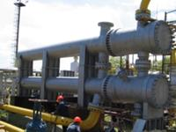
Heat exchanger of
"Shell-and-tube" type
 | 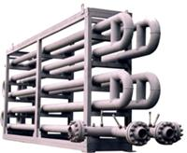
Heat exchanger of
"Pipe-in-pipe" type

3.2.5 Shutoff and regulating valves
Shutoff and regulating valves are intended for use as shutoff devices in the systems with different neutral and aggressive liquids, emulsions, suspensions, gases, as well as for adjustment of gas flow by change of open flow area of the control.
General quantity of mastered by the company articles is more than 60 designations, which embrace port areas from 6 to 1000 mm at pressure from 1.6 to 105.0 МPа for different operating mediums with the temperature from minus 40 to plus 1200С.
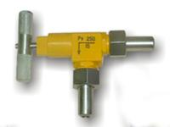  VU 10/250 corner valve | 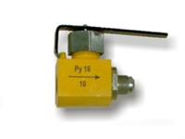  КRP-1.6-10 ball-cage cock | 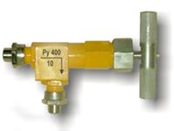  VU 10/400 corner valve
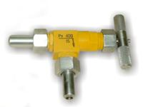  VU 15/400 corner valve | 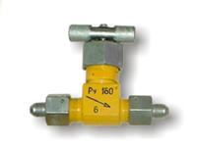  VZN 6/160 Valve | 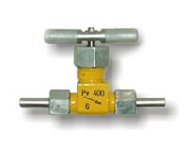  VZN 6/400 valve
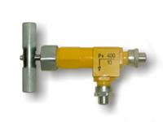  VU 10/400 corner valve | 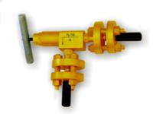  VU 10/700 corner valve

Nos. | Designation | Specifications |  |  |  | Leakproofness of gate | Weight, kg
Nos. | Designation | Pressure, МPа (kgf/сm2) | Internal area, mm | Operating medium | Ambient air temperature, °С | Leakproofness of gate | Weight, kg
1 | VZN 6/250 shutoff valve, nipple | 25(250) | 6 | Natural gas, hydrocarbon oils, aggressive liquids, emulsions, suspensions | -30 до 80 | as per GOST 9544-93  grade А | 0,40
 |  |  |  |  |  |  | 0,45
2 | VZN 6/400 shutoff valve, nipple | 40(400) | 6
 |  |  |  |  |  |  | 0,50
 |  |  |  |  |  |  | 1,10
 |  |  |  |  |  |  | 1,20
3 | VZN 10/400-01 shutoff valve | 40(400) | 10
 |  |  |  |  |  |  | 1,30
4 | VU 10/250 angle valve | 25(250) | 10
 |  |  |  |  |  |  | 2,30
5 | VU 10/400 angle valve | 40 (400) | 10
 |  |  |  |  |  |  | 1,15
 |  |  |  |  |  |  | 1,20
6 | VU 10/400-ОК angle valve with non-return valve | 40(400) | 10
 |  |  |  |  |  |  | 1,20
 |  |  |  |  |  | as per GOST 9544-93  grade С | 1,25
7 | VU 10/700 angle valve | 70 (700) | 10
 |  |  |  |  |  |  | 1,75
8 | VU 15/250 angle valve | 25(250) | 15
 |  |  |  |  |  |  | 1,80
 |  |  |  |  |  |  | 3,50
9 | VU 15/400 angle valve | 40(400) | 15
0,70
1,60
8,60
10,0
10 | VU 15/400-01 angle valve | 40(400) | 15
11 | ККN 20 two way valve | 6,3 (63) | 20
 |  |  |  |  |  | as per GOST 9544-93  grade А | 0,40
12 | КSh 20/100 four way valve | 10(100) | 20
 |  |  |  |  |  |  | 0,45
13 | КR-1 ball-cage cock | 32(320) | 10 | Natural gas, hydrocarbon oils | -30 до 50 | as per GOST 9544-93  grade А | 0,45
14 | КР-2 ball-cage three way cock | 32(320) | 10
15 | Ball-cage cock:  КRP-1,6-15 (G1/2») КRP-1.6-25 (G1») КRP-1,б-50(for welding)  КRP-1,6-50 (flange) | 1,6(16) 1,6(16) 1,6(16)  1,6(16) | 15  25  50  50 | Natural gas, hydrocarbon oils, aggressive liquids, emulsions, suspensions | -30 до 50 | as per GOST 9544-93  grade А | 0,45
 |  |  |  |  | -30 до 80 | as per GOST 9544-93  grade А | 0,45
16 | 6/250 vent for pressure-gauge | 25(250) | 6
17 | 6/400 vent for pressure-gauge | 40(400) | 6

3.2.6 К-203P valve
The valve is intended for systems of automatic adjustment of liquid flow in mail pipeline depending on control commands of remote control of production processes.
Workspace - oil products, inhibitor, deposit waters.

Actuating Mechanism includes: two membrane pneumatic control valves, rotating mechanism and flap. Signaling device of threshold level is set in level chamber.
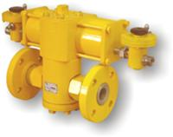 | 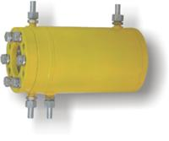 | 

Main specifications
Designation | Value
Internal diameter dy, mm | 40
Operating fluid temperature, °С | from minus 30 to 80
Ambient air temperature, °С | from minus 30 to 50
Relative ambient air humidity throughout the whole range of temperatures, % | 30...98
Ambient air pollution class according to GOST 17433-80 | 5
Air pressure in the system of valve control, kgf/сm2 | 5±1
Maximum operating medium pressure in the main pipeline, kgf/cm2, max | 160
Leakproofness of the gate according to GOST 9544 -93 | С
Weight, kg, max. | 45
Connection type | Flanged, under lens seal
Service life time before retirement, years, min. | 5
Mean life before retirement, cycles, min. | 5 000
Mean-time-between-failures, cycles, min. | 1600
Mean life before the first failure, cycles, min. | 1700
Mean recovery time, hours, max. | 12

4. Servicing

After-sales service
Basing on the long experience, along with the supply of the equipment of «Turbogaz» PJSC renders services of patronage surveillance for performance of construction-installation works, commissioning, training of the servicing personnel, as well as performs guarantee and post guarantee after-sales service. Performance of the whole complex of works in this direction is made by special department of assembly, commissioning works and servicing.
Important factor, which influences effectiveness of work of equipment, is timely and quality performance of technical servicing and repairs – one of the most important tasks, on solving of which directly depends reliability of its work. At «Turbogaz» PJSC was developed the track and equipment servicing system, which provided guarantee servicing during 1 year after introduction of the plant in operation. Providing of correct operation in this period creates necessary preconditions for fail-safe work of equipment during all service life. That is why at this period specialists of the joint stock company pay special attention to control for following the modes of operation of the unit and performance of regular instructions of the servicing personnel. During the guarantee period the Customer has a right for free of charge technical servicing, as well as obtaining of qualified consultations.
  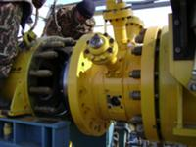
  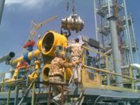
  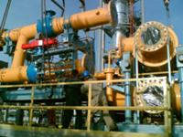
  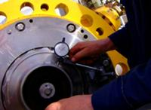
  
  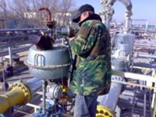

After termination of a guarantee period, post-warranty servicing and if necessary, supply of spare parts is provided by a separate Contract. In constructions by «Turbogaz» PJSC turbine expanders is used the assembly-node way of design of units, that allows providing quick and easy disassembly for large nods and components, as well as replace separate nods and parts.
Aimed to provide more quality rendering of services and organize close cooperation with customers. In 2006 «Turbogaz» PJSC opened representative office in the Republic of Uzbekistan.
«Turbogaz» PJSC performs individual training of the servicing personnel directly on site in the process of commissioning, that allows reducing time for mastering of this type of techniques and reducing possibility of unauthorized activities at operation of the unit, which can cause its malfunction. Learning of structure and mode of operation of automatic control system, execution of skills of operation in the modes of debugging automatic control system, execution of startup and shutdown modes of the unit taking into consideration the peculiarities of technology are also vitally important for training, with the following issue of a certificate.
Approach, which «Turbogaz» PJSC uses in its work organizing a system of accompaniment and servicing of units, is directed for reduction of terms of implementation of the supplied equipment, providing reliable and trouble-free operation of the equipment during the whole period of its operation and, as a result, increase of the Customer’s profit.

5. Contacts
 | Name, surname, position | Tel.
 | Chairman of the Supervisory Board  Oleg Semenovich Ilyutko | Tel. (057) 7151609
 | Chairman of the Board  Oleg Viktorovich Kuprygin | Tel. (057) 7151609  Fax(057) 7314554
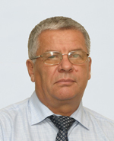 | Chief Engineer,  deputy Chairman of the Board  Sergei Viktorovich Moiseiev | Tel.(057) 7151621  Fax(057) 7315209
 | Director on marketing,  sales and development,  Member of the Board  Elena Vilyevna Pastukhova | Tel.(057) 7151613
 | Director on procurement  Dmytro Valentinovich Kaliamin | Tel.(057) 7151613

Address
61003, Kharkov,
Dubovogo lane, 6/4
Tel./fax: (+38 0 57) 731-45-54
Tel.: (+38 0 57) 715-20-54
Tel.: (+38 0 57) 715-20-56
www.turbogaz.com.ua
turbogaz@ukr.net

Representative office in the Republic of Uzbekistan
Republic of Uzbekistan,
Tashkent,
Pushkina str., 59
Director
Shaizakov Kamoliddin Gairatovich
Tel./fax: +998 (71) 237-10-07 uzturbogaz@gmail.com

